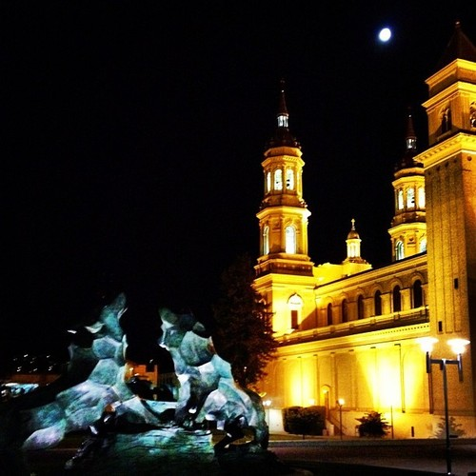
USF Climate Action Plan 2013:
Transportation

By: Sarah Lund And
Jessica Chang

Table of Contents

  - Incentives not to drive…………………………………………………......…3-4
  - Biking at the University of San Francisco …...................................................4-6
  - Jobs and Housing .............................................................................................7-8
  - Transportation on Campus..............................................................................8-10
  - Works Cited........................................................................................................12

Section 1.1: Incentives not to drive:

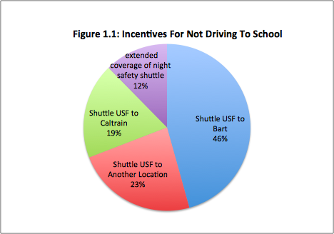
The University of San Francisco could have a variety of ways to give students and faculty incentives to not drive to school. This can be accomplished through convenience or monetary incentives. The most obvious way the incentives people to not drive to school would be through convenience. If you can convince people that driving to school is not the most efficient way of travel then people will not drive. In a survey put out by USF and put into their master plan they show that “when asked, ‘Why do you typically drive alone to campus?’, 41% of drivers stated that they have no reasonable transit option, 7% stated that transit does not run late enough and 4% stated that they do not know which transit route to take. When asked, ‘If you currently drive alone to campus, what would encourage you to use an alternative to driving alone?,’ 37% of drivers responded a shuttle connecting USF to BART; 19% stated a shuttle connecting USF to another location; 15% responded a shuttle connecting USF to Caltrain; and 10% stated an extended area of coverage for the night safety shuttle". (Figure 1.1) This data shows that 80% of drivers would be willing to give up their car if there was a shuttle that drove students to and from campus to various locations.
Other schools in San Francisco such as UCSF have implemented very successful shuttle services. UCSF has a shuttle service that has a 15 mile radius that serviced 2.2 million passengers in 2008/09.² They have 53 busses and 15 routes in place that drastically reduce the need for faculty and students to drive to work because it is much more convenient to utilize the free shuttle service. Other urban schools such as NYU provide a free shuttle service throughout the city which is available to all faculty and students.³ They did a survey of students who said that 26% use the shuttle this as their main source of transportation and less than 1% of their student body drives a car. The University of San Francisco has all of the resources necessary to implement a shuttle service like other urban schools all over the country are doing. This shuttle would also be a large driving factor for students to attend the university because parents and students would feel much more safe in such an urban environment.
Monetary incentives could be implemented to people who decide not to drive to campus. This could be done through adding Dons Dollars to students accounts who utilize public transport, biking, or any other method of non motorized transport. A survey sent out by USFPedals, the bicycle group on campus, showed that when students were asked “Which of the following would be the most likely to persuade you to bike to/from/around campus?” 36.0% responded “receiving a monetary incentive”. They concluded that this could be done through $20-$50 in Dons Dollars to registered bicycle commuters which could be monitored by OneCard swipes or RFID technology. This is similar to the $65 commuter checks that USF already offers. This type of program has been already successfully implemented at Stanford, Cal State Fullerton, Oregon Health Sciences University, and elsewhere⁴ In a survey that was sent out by the students in Environmental Policy they asked the environmental department “what would be an incentive for you to give up driving to school?” 40% of the respondents said that a monetary incentive would be the most impactful.
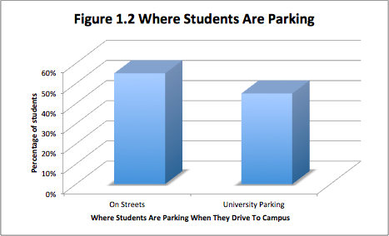
In the University of San Francisco’s Master Plan: Traffic Calming Section, they gave numbers that said 55% of students who are driving to campus park on the streets (Figure 1.2).⁵
A incentive that often times goes unsaid when thinking about how to deter students from driving to campus is the reduced risk of tickets or theft. It is far too common that around the University of San Francisco cars are broken into and ticketed far too often. The University could implement an advertising scheme that would tell of the other means on arriving to campus and list as incentives the harmful things that can come with using street parking. On street parking cars are not watched over by USF Faculty and therefore are at higher risk.

1.2: Bicycling around University of San Francisco

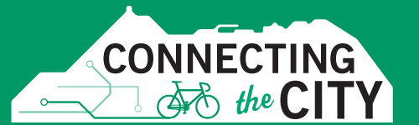

“The San Francisco Advantage” is what all the students from across the world come looking for; it is a combination of a healthy, human-scale, environmentally friendly and socially just form of transportation. It is a perfect way to connect us to the city by exploring bicycling routes for a smooth and safer ride around the bustling streets of San Francisco. While bicycling may seem like a perfect opportunity to play a key role in reducing carbon emission, many students on campus find it a hassle or dangerous to bring a bike to school. According to the USF bicycle transportation plan1 respondents from a bike survey stated if, “There was a place to lock a bike that was more secure than a bike rack,” while 80% of respondents would ride their bike to campus if “There were indoor options for locking/storing my bike.”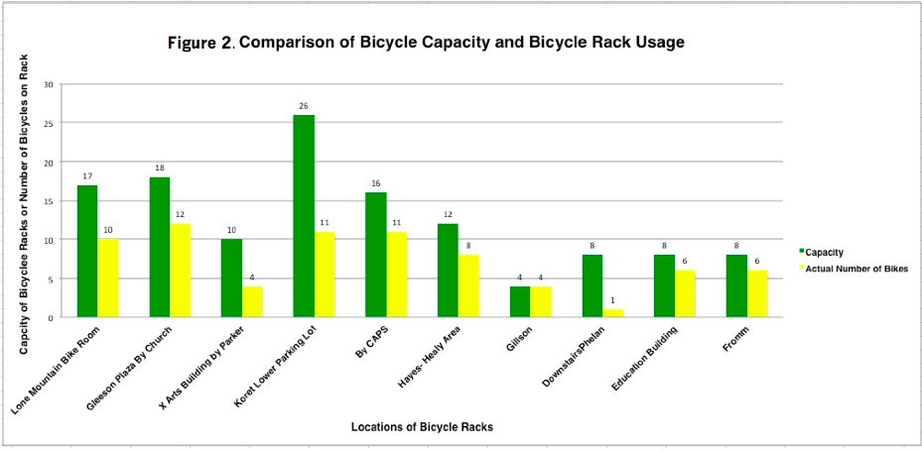
The initial USF bicycle transportation plan established a relationship with the City of San Francisco to achieve a 20% goal of all trips on bicycle by 2020. By achieving this goal, the Bike transportation plan set goals to prioritize the immediate construction of short-term, centralized covered and secure bicycle parking, expand capacity of covered, secure bike parking for the next 5 years, add conventional bike racks, integrate space into new covered bike parking construction for a bike facility (i.e. bike repair station), connect the campus to existing bike routes in the city by collaborating with the San Francisco Metropolitan Transportation Agency as they plan to redesign major streets around the USF neighborhoods, hire trained students or faculty members to facilitate a bicycle commuting program, develop websites, maps, and brochures to educate USF bicyclists in finding safe, least hilly routes to their destination, and pilot a small bicycling program. These implementations of these projects must come from the University’s community to help establish an order of projects on which implementation will be continued and how soon they will happen.
The community around USF is building a culture of respect on our city streets. For example, the San Francisco Bike Coalition2 established many bike courses to teach the community on how to safely ride a bike on the streets. Through their education work, they are the leading resources for bicycle safety information in the city2. Their free instructional course provides people who bicycle to learn how to navigate around taxis, cars, and Muni drivers. They learn about their rights and responsibilities on the road, by studying the bicycle laws of the road and how to safely and legally bike around San Francisco.
Important bike policies in San Francisco help us understand our rights and responsibilities on the road. Their policies are a leading resource for bike safety education today. Nine important rules2 implemented in bicycling that helps us lead a safer ride are as follows, (1) pedestrians have the right of way-in crosswalks, bikes and drivers are required to yield to pedestrians, (2) stop behind the crosswalk-always stop behind the line so crosswalk is free and clear for pedestrians, (3) Mind the signs and lights-obey right lights and stop signs, (4) stay on the streets-illegal to ride on sidewalk unless you are over the age of 13, (5) go with the flow-ride in the same direction of traffic, (6) take the lane-if you’re next to a parker car-take the lane and ride outside the door zone, (7) its okay to leave the bike lane-if you feel safer outside the bike lane, you can ride in other vehicle travel lanes. Merge when safe and signal when changing lanes, (8) use reflectors-reflectors and a front white light are required by law, (9) keep ear clean-no playing music, drivers and bikers are required to keep one ear free.
The SF Bike Coalition plans to connect bicyclers to the city by addressing questions of how to make San Francisco an easy place to live, shop, work and play in2. The SF Bike Coalition plans to work with the SF Metropolitan Transportation Agency to redesign the city’s streets to make it more bikeable for everyone from an 8 year old kid to an 80 year old grandmother, thanks to their recent improvements like the Market Street separated bike lanes and events like Sunday streets (a 71% increase in bicycling in the past 5 years since 2010)3 is a clear example that more San Franciscans want to get around the city on a bike.
Some new improvements on the streets have also been happening around the USF campus such as, a dedicated bicycle traffic light3 at Fell and Masonic and Green Wave on Valencia, to the Scott street green bike box and dedicated left turn lane for cyclists on The Wiggle3 turning onto Fell Street. The Masonic Avenue Redesign2 will make Masonic and 2nd street a more complete street, to provide safety for the bikers in that area. The Oak and Fell Street Separated Bikeways Project will safety connect the Wiggle to the Panhandle. The SFMTA Board of Directors began construction on the Oak and Fell Street project on May 2013 that separated the bike street from the automobile street. This bikeway would improve a vital bicycling link on three blocks between the Wiggle route and the Panhandle, would replace up to 80 parking spaces for bicycle reconstruction.
All of these initiatives have helped reduced our carbon emission. Riding a bike cuts back our fuel emission completely4. Bikers provide a more cleaner and healthier form of transportation. They also cut down cars on the road, that way less traffic is congested on the streets. Bicycling produces fewer production emissions, because the small size of the bike requires less energy compared to a car. Building a car requires more metals and energy usage that releases more carbon emissions in the air. The metals to make cars most often are mined from the Earth, which can destroy land and cause deforestation4. Compared to a bike it takes less metals and energy usage, it reduces carbon footprint because you are using existing materials and not using materials that produces more emission. Bikes take up less space on the road, with fewer cars on the road it will demand space for bike routes, street trees, and adding green spaces like pocket parks that will make the city more green and environmentally friendly4.
USF has implemented bike measures for the community and students by adding more bike racks throughout campus5, they started to put in more bike stalls in safer areas; for example, the new CSI building has a new bike stall between the Harney Science Center and the CSI building. This area is safer because it is located in an active place, where students can witness someone stealing a bike in that area. USF bike policy6 stated that bikes must be parked only in areas with a bike rack. There are other restrictions that prohibit us to not bring the bike on stairs, fire lanes, or park in car spaces. The USF bike policy also stated that any bike that is locked anywhere (not on a bike rack) has no liability for it when it gets stolen or damaged. With clear constructive policies, these will help students understand the importance of riding a bike to school.

2 SF Bike Coalitions, 2012
3 SF Metropolitan Transportation Agency, 2013
4 Melanie J. Martin, 2011-SF Gate
5 Transportation-University of San Francisco, 2013
6 USF Department of Public Safety, 2010

1.3: Jobs and Housing at the University of San Francisco

There are over 1,000 USF employees and many students who live in San Francisco. The median household income is $78,840, the maximum affordable home “within reach” of middle class is $409,000, homeownership is less attainable year-over-year. The Percentage of homes for sale within reach of middle class in 2012 is 24% and the percentage of homes for sale within reach of middle class in 2013 is 14%”. “In Fall 2011, USF provided 2,045 beds of student housing on the Hilltop Campus, plus another 93 student beds off campus at Pedro Arrupe Hall, 490 6th Avenue. Together these facilities accommodate 38% of the undergraduate student population.”² Many other universities that are similar in scale and location to the University of San Francisco provide at least 50-60% of students and faculty with on campus housing. This prevents people from needing to live outside of the city due to lack of housing availability and affordability. If USF provided more on campus housing for students we could drastically reduce the amount of travel to and from campus. The University has set into motion through it’s master plan that it will add 635 new bedrooms that will be built over a 160 car parking garage.³ This will be beneficial because that is 1270 less commuters that we will have driving into school, given the assumption that there will be 2 people in every room.
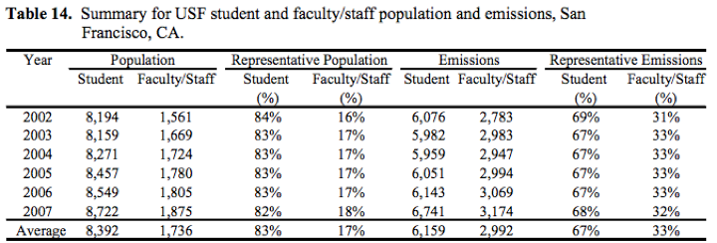
Although the students of the University of San Francisco and their commuting did account for 60% of the transport emissions in 2007, the faculty is only 16% of the population and accounted for 28% through their commuting (Table 14).⁴ Many of the faculty members at USF drive into work. If the university provided subsidized housing for teachers and their families close to the school then there would be much less commuting because they would be able to afford to live in the city and not need a car. The university currently does not provide housing for teachers and does not have any future plans to do so.
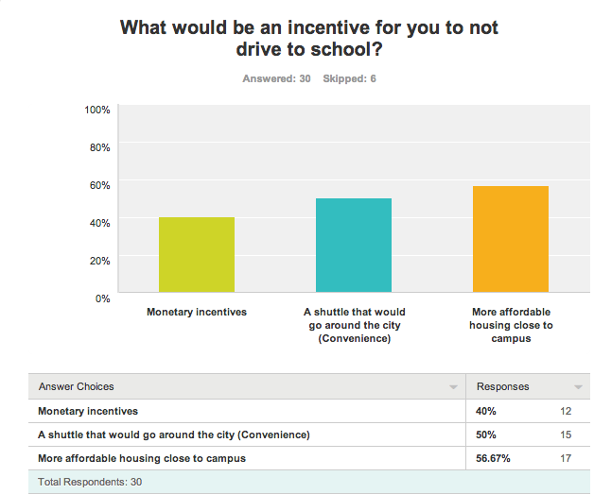
Most of the University of San Francisco’s residence halls have not been updated or built since the 1960s. This can be a major deterrent from having students live on campus and therefore not need to drive. Other comparative universities such as Saint Mary’s University and Santa Clara University have had much more recent updates to their dormitories and on campus housing which has also lead them to having a higher percentage of students live on campus. A survey that was sent out to the environmental students and faculty asked, “What would be an incentive for you not to drive to school?” and the responses are shown in the figure below. 56.67% of respondents stated that more affordable housing close to campus would be a big incentive to not drive. This clearly shows that there is a lack of valid options for the students and faculty close to campus. The same survey asked, “Do you think that the university offers enough campus housing?” and 90% of respondents said that they do not.
San Francisco has one of the most advanced and developed public transportation systems in America. Although it may seem that with the bart, muni, and caltrain that there is really no reason to drive when you live close to the city. However, this can often be hard for people who are trying to commute from the east bay or south bay with the sometimes unreliability of the trains and the unpredictable strikes. If USF provided a shuttle service or bus service for those people it would create sustainable jobs on campus for students our outside community members and it would drastically reduce our carbon footprint. Providing a shuttle service would also create more on campus green jobs that in turn promote sustainability while providing for the students.
Green jobs on campus are one way to promote awareness for sustainability all over campus and the city. USF has such a large impact on the city at wide and if we implemented more sustainable jobs on campus it could have drastic effects on the entire city. Transportation could be our way to provide sustainable jobs and promote student involvement. Green jobs such as, shuttle drivers for students, bicycle safety officers, bicycle facility workers/ repairmen, green educators on campus to communicate the best ways to get to school, etc.

1.4: Transportation on Campus

University of San Francisco is located on a 55-acre setting between the Golden Gate Bridge and Golden Gate Park. Settled on a hilltop located on San Francisco’s major hills is Lone Mountain. The school offers the “San Francisco Advantage” that connects the University with the heart of the city. The public transit system plays an important part in connecting the University and city together. The San Francisco MUNI and BART are minutes away from the University. The 5, 44, 31, 38 MUNI bus line stops in front of the University campus, and the BART is only a 10-15 minute bus ride away. According to the California Air Resource Board (CARB)1, the transportation sector in California is the largest source of greenhouse gases, making up to 40% of the state total emission. UCSF2 has stated that, the amount of transportation sector contributes to greenhouse gas is dependent on the length of trips, and the type of vehicle we use. The type of vehicle we use can translate to greater carbon emission. UCSF believes that GHG emission has to do with two types of interrelated actions2. These are: 1) addressing the jobs/housing imbalance and 2) improvements to campus transportation system. Walking and biking produce zero carbon emission, and a public transit system produces about half as much as many GHG emission compared to riding a car to campus2.
The Bay Area has one of the most developed public transit system in the U.S. carrying about 1.3 million riders a day3. The MUNI carried about 46 percent of the San Francisco’s population, BART carried 21 percent, Alameda-Contra Costa Transit District (AC Transit) carried 14 percent, Santa Clara Valley Transportation Authority Carried 8 percent, the San Mateo County Transit District 3 percent, Golden Gate Transit 2 percent, Caltrain 2 percent and all others 5 percent3.
This serves as the central hub of Bay Area’s transportation system, which carries over 1.3 million riders a day3. This covers about 35% of all work trips on a public transit system. San Francisco dense city; has one of the highest walking and bicycling in the country. About 10.4% of work trips are done by walking and 2.7% of work trips are done by bicycling. This shows a major improvement in the GHG emission if people are starting to walk and bike more around the city.
There are several ways for a University of San Francisco student to get to and from campus. With new improved technologies there are numerous commuter incentive programs and services for students to take advantage of. New services like zimride, lyft, and uber are competing against taxi fares for a lower price, which offers students an incentive to use those services instead of a taxi. USF has also provided new bike racks and bike stalls throughout campus, there’s also a free rideshare program which you can signup and carpool with someone that has the same commuting schedules as you-these rideshares offer incentives including free bridge tolls during peak commute hours and use of carpool lanes, USF has 10 Zipcars (6 in the Upper Koret lot and 4 in the Loyola lot). Students 18+ can apply to use the car4. USF also offers a night shuttle service for students that live off campus; the shuttle can only travel between Pedro Arrupe (a USF off campus dorm) on 6th and Balboa to Divisadero st towards downtown. The City of San Francisco is known for its highly developed public transit system. SF MUNI offers numerous transit vehicles such as, cable cars, streetcars, buses, metro, and lightrail. The University offers students a transit subsidy every semester; it provides students a MUNI bus pass that is included in their tuition. The USF Master Plan5 states that, about 537 students and faculty walk, 535 drives, 475 takes the public transit, and 95 carpool to and from campus.
According to the USF Master Plan5, the general plan of San Francisco for environmental protection is to focus their objective on the ambient air of San Francisco and the bay region is clean, provides maximum visibility and meets air quality standard. They are doing this by reducing transportation related noise. Their main policy 4.25 focuses on encouraging the development and use of urban mass transportation system with the objectives and policies of the transportation element. Policy 9.25 wants to impose traffic restriction to reduce transportation noise.
USF has created a Time-division multiplexing (TDM) strategy that focuses on the use of public transportation systems to decrease the number of drivers arriving on campus. The University focuses on working with their neighbors and the students on how to reduce transportation noise where feasible. By doing this, the University established strict restrictions on delivery times. They plan on having deliveries take place off of Golden Gate Avenue.
TDM goals5 are to reduce USF community vehicle trips from traveling to and from campus. This plan will protect pedestrian safety, reduce vehicle emissions, and improve neighborhood quality of life. These are the specific goals of the TDM: reduce future parking by 13% in 2022, identify strategies to operate the TDM program on a cost-neutral basis, meet the needs of the University while fulfilling the City of San Francisco’s requirements minimizing impact that surround the neighborhood, and implement a continuous system to track progress of TDM measures to achieve required parking demand reduction. The comprehensive TDM strategy goal is used for increasing travel demand to and from campus, this will hopefully achieve management and construction plans to mitigate loading and construction impacts on the streets around USF.

1 California Air Resource Board, 2013
2 University of California- San Francisco Climate Action Plan, 2009
3 MTC/Caltrans State of the System Report. 2007
4 Transportation-University of San Francisco, 2011
5 University of San Francisco Institutional Master Plan, 2012

Works Cited

1 California Air Resource Board, 2013
< http://www.arb.ca.gov/homepage.htm>
2 University of California- San Francisco Climate Action Plan, 2009 <http://sustainability.universityofcalifornia.edu/documents/ucsf_cap_09.pdf >
3 MTC/Caltrans State of the System Report. 2007 <http://www.mtc.ca.gov/library/state_of_the_system/state_of_the_system-05.pdf>
4 Transportation-University of San Francisco, Department of Public Safety, 2011
< http://www.usfca.edu/Public_Safety/Transportation/>
5 University of San Francisco Institutional Master Plan, 2012
<http://www.usfca.edu/Business_and_Finance/Project_Management/Master_Plan_Documentation/>
Erwert , Anna Marie. "On the Block" SFGate 21 Oct. 2013 : 2-17.
< http://blog.sfgate.com/ontheblock/category/national/>
⁴ USF Campus Carbon Inventory, Transportation Survey 2008
2 SF Bike Coalition, 2012
< http://www.sfbike.org/?resources >
3 SF Metropolitan Transportation Agency, 2013
<http://www.sfmta.com/getting-around/transit >
4 Martin, Melanie J. (10 May 2013). How Does Car Pollution Affect the Weather. SF Gate, p. 1-4. < http://homeguides.sfgate.com/car-pollution-affect-weather-79357.html>
³ NYU Climate Action Plan, 2010
< http://www.nyu.edu/about/news-publications/news/2010/03/12/nyu_releases_climate.html>
⁴ USFPedals, ENVA 109 class, 2011
< http://www.usfpedals.org/bicycle-plan.html>

USF Master Plan, 2013 ²UCSF Climate Action Plan, 2009 ³ NYU Climate Action Plan, 2010 ⁴ USFPedals Survey, 2011
Anna Marie Erwert, SF Gate, 2013 ²University of San Francisco Master Plan 2013 ³University of San Francisco Master Plan, 2013 ⁴ USF Campus Carbon Inventory, Transportation Survey 2008

