Sarah Lund
Intro To Urban Agriculture
Professor Rue Ziegler
November 3, 2014

Paper #2: Female Headed Households in San Francisco & Food Insecurity

Introduction
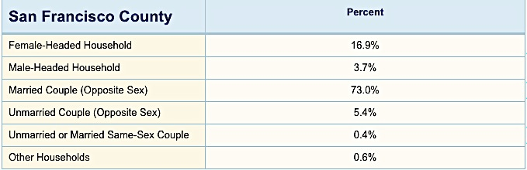
Female-headed households are at great risk for food insecurity in the bay area. I chose to focus my research on this group for two reasons; one reason is that I live in the Bay Area so it is a location that hits very close to home. The second reason is that I am a woman and I know many single mothers and I am extremely interested in what puts them at risk and the circumstances surrounding their food insecurity. This group is food insecure because women tend to make less money than men do and they have children, which is a huge added expense. The mother’s lack of income can lead to the family or unit having to live in an area without a full service grocery store, also known as a food desert. The moms or women that are running the house often cannot get enough food to feed everyone living there so they will partake in maternal buffering, which is when a mother skips meals or food in order for her children to eat. This is a huge issue for all of us because approximately 17% of all households in San Francisco with kids are female-headed households (as shown on the table to the right). This is a huge number of women and kids that are being affected by food insecurity and this will affect the health of these families and their abilities to succeed in the future.

Food Insecurity and America
Food security can be attained if you have 5 criteria. The criteria are having access to food, as well as having healthy, culturally appropriate, affordable, and safe food. Feeding America states, “In 2013, 49.1 million Americans lived in food insecure households, including 33.3 million adults and 15.8 million children.” This means that 1 in 5 kids are at risk for being food insecure and could be hindered in reaching their full potential in school due to lack of nutrition. On top of the kids lacking proper nutrition there is an astounding 39.5% of the population, adults and kids that are living with food insecurity. This is a massive problem that we need to start addressing because we have the resources in America to put an end to this problem. In America we have much more food than we could ever eat yet people are still not getting proper nutrition. A small part of this can be due to our exporting of food. The USDA states that “Historically, bulk commodities-wheat, rice, coarse grains, oilseeds, cotton, and tobacco-accounted for most of U.S. agricultural exports. However, in the 1990s, U.S. exports of high-value products (HVP)-meats, poultry, live animals, oilseed meals, vegetable oils, fruits, vegetables, and beverages-showed steady growth, while exports of bulk commodities tended to fluctuate more widely, particularly in response to global supplies and prices.” These are huge items in the food market today but this is not the main reason for food insecurity today in America, as one would imagine. The USDA also states “In 2012, 56.6 pounds of chicken per person on a boneless, edible basis were available for Americans to eat, compared to 54.5 pounds of beef.” So why are there so many people going hungry today? The main reason for food insecurity is unequal distribution. There is plenty of food on grocery store shelves to feed many more people but they just do not have the means to afford this food or live in areas where they do not have access to places where healthy food is sold.
The criteria provided for being completely food secure are having access to food, as well as having healthy, culturally appropriate, affordable, and safe food. This can be hindered in a variety of ways. The first way someone in America could be lacking some aspects of food security is if they are a specific religious group that doesn’t eat certain food groups or come from a background where they make specific recipes and they cannot get the ingredients or food that is culturally appropriate for them. Another very common way people are becoming food insecure is that they cannot afford to buy fresh produce for their families so they end up buying a meal from McDonalds so they are getting an excess of fat, sugar, and salts, and not the proper nutrition that they need. This is called nutrition transition and it is very common in rural areas and it basically means that there is a change in diets to containing more meat, fat, and sugar, which can lead to non-communicable diseases. Another way that people are loosing their food security in America is if they have to buy extremely cheap food or stealing expired food and it could be a health risk for their families. People have a right to food that is not full of pesticides and harmful chemicals but it can often be the case that the most unsafe foods are the cheapest to make and easiest to attain.

Female Headed Houses in San Francisco in Relation to Food Insecurity
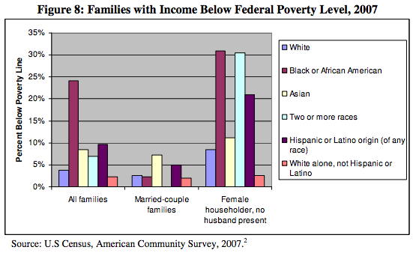
City and County of San Francisco Department on the Status of Women did a comprehensive study in 2009 where they studied women in San Francisco and their rates of poverty, education, and employment. The graph to the right shows income and poverty levels for different types of families in San Francisco. This shows that all ethnicity groups are more at risk for being below the poverty level if they are a female householder. They also found that “In 2005, 63% of women participated in the San Francisco labor force, representing 46% of the total labor force in the City.” Even if women are involved in the workforce the study states “Women, on average, earned 78% of men’s earnings in San Francisco, a pattern that is mirrored nationally. The pay gap is the largest for women with graduate or professional degrees, with these women earning 66% of men’s earnings. The pay gap also differs by race, widening tremendously for women of color.” This demonstrates that women are making up less than half of the work force when they account for half of the population and approximately Two thirds of women participated in the work force at all. In San Francisco, 16.5% of our population is categorized as food insecure. Out of all the food insecure groups in America, 36.8% of the people who are food insecure are female-headed households (see the graph on the next page). If we apply this number to the percentage of people who are food insecure we can get an estimate of what the percentage of female headed households we have that are insecure in San Francisco. This means that 6% of our entire population in San Francisco is female headed households that are food insecure. One of the problems that female-headed households could be facing in San Francisco is if they live in an area like the Tenderloin where there are food desserts and they do not have access to a full service grocery store. Not having access immediately makes you food insecure with the definition that was provided earlier in the paper.
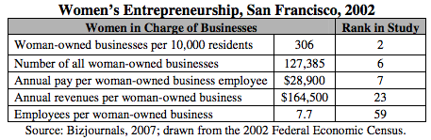
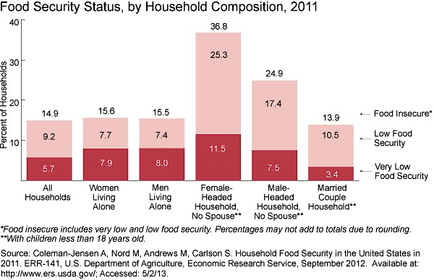
The main causes of this group being food insecure are that women get paid 77% of what men get paid, they only have one income, they have kids that they need to care for, and when women get pregnant they have to take time off without being paid. California’s census data also shows that they had an 8.9% unemployment rate in 2013 and this also encompass’ the female headed households. If you take a look at the chart below you see that only 3% of businesses in 2002 were owned by woman, this shows that woman do not have the economic resources or the support to start their own business and even if they do their employees are making a very small salary ($28,900). These are all factors that are working against woman and it makes it extremely difficult to be food secure in these circumstances. Female-headed households run into one very common consequence of being food insecure, which is known as maternal buffering. This means that a mother is skipping meals in order to feed her kids and this automatically means that the mother is food insecure because she is not getting all of the nutrition that she needs. Other consequences of being food insecure are that moms will need to adapt coping strategies. These can be borrowing food or money from neighbors, change in their diets, stealing food, eating less, begging for food, or skipping entire meals altogether.

Evaluating food Insecurity
According to the UN there are 5 ways to classify if you are food insecure:
- Generally food secure
- Chronically food insecure
- Acute food and livelihood crisis
- Humanitarian emergency
- Famine/ Humanitarian catastrophe
Based on these rankings I would say that female-headed households could be categorized as chronically food insecure. Caloric intake in can be insufficient for woman in a variety of ways as discussed above, they can be eating far too many of the wrong types of calories or they can be skipping meals and not getting nearly enough calories to survive. Some of the specific problems with food access are that women that are bringing in only one income often have to live in poorer areas, such as the Tenderloin. These areas are known as food desserts and do not have a full service grocery store that is easy to get to. This leads to women having to buy all of their food at the corner liqueur store and these stores do not have fresh produce or healthy options for meals.
There are a few main groups that are available for women who are food insecure to use to help them with their nutritional needs. Feeding America lists of statistic saying “In 2013, 62 percent of food-insecure households participated in at least one of the three major federal food assistance programs –Supplemental Nutrition Assistance Program (SNAP-formerly Food Stamp Program), The National School Lunch Program (NSLP), and the Special Supplemental Nutrition Program for Women, Infants, and Children (WIC).” As far as female-headed households go the most helpful group would be WIC as it is catered specifically for women and their kids. The WIC clinic has 6 locations in San Francisco and makes it very easily accessible for woman in the city. The San Francisco Department of Public Health describes the WIC program as “The WIC Program provides supplemental foods (such as milk, cheese, cereal, eggs, beans, peanut butter, and juice), nutrition education, breastfeeding education and support, and referral to health care and community services.”

Conclusion
Throughout this paper I have learned just how much more at risk woman are for food insecurity. The research I reviewed shows that female-headed households are the most at risk group for food insecurity due to a variety of factors. In order to solve this problem we are going to need to work with groups like Feeding America and other non-profits to provide females with families more resources to food and assistance in weekly meal planning. I would recommend giving more resources to the WIC program and make it accessible to women even if they have a child who is over 5 years of age (because that is the usual cut off for that program). This way the program could support the mother and child all throughout the kid’s life and help to reduce their food insecurity. The USDA reports the funding for WIC and says “Congress appropriated $6.522 billion for WIC in FY 2013. By comparison, the WIC Program appropriation was $20.6 million in 1974; $750 million in 1980; $2.1 billion in 1990, $4.0 billion in 2000, and $7.3 billion in 2010.” This shows that although the funding has gone up from the 70’s but there has been a substantial drop in funding from the funding that was provided in 2010. If we could raise the funding back to where it was I think that the extra money could drastically improve the program and be able to help more women for a longer time.

Sources:

Coleman-Jensen, Alisha. Household Food Security in the United States in 2011. S.l.: Bibliogov, 2013. United States Department of Agriculture. United States Department of Agriculture. Web. 01 Nov. 2014.

Insecurity, Hunger And Food. "Hunger and Food Insecurity ON THE RISE in San Francisco." San Francisco Food Security Task Force (n.d.): n. pag. Nov. 2010. Web. Nov. 2014. <http://www.sfdph.org/dph/files/mtgsGrps/FoodSecTaskFrc/docs/2010_FSTF _AnnualReportfinal.pdf>.

"Map the Meal Gap." Feeding America. N.p., n.d. Web. 01 Nov. 2014.
http://www.feedingamerica.org/hunger-in-america/our-research/map-the-meal-gap/

"Report of President's Commission on the Status of Women." Monthly Labor Review 86.10 (1963): 1166-169. City and County of San Francisco Department on the Status of Women, 2009. Web. Oct. 2014. <http://sfgov.org/dosw/sites/sfgov.org.dosw/files/migrated/FileCenter/Docume nts/dosw/Reports/report_on_women_exec_summary.pdf>.

"San Francisco Nutrition Services." Department of Public Health. San Francisco Department of Public Health, 2014. Web. 03 Nov. 2014. <http://www.sfdph.org/dph/comupg/oprograms/NutritionSvcs/WIC/WIClocatio ns.asp>.

U.S. Department of Health and Human Services, Health Resources and Services Administration, Maternal and Child Health Bureau. Women's Health USA 2013. Rockville, Maryland: U.S. Department of Health and Human Services, 2013.

"USDA ERS - U.S. Agricultural Trade: Exports." USDA ERS - U.S. Agricultural Trade: Exports. United States Department of Agriculture, Sept. 2012. Web. 04 Nov. 2014. <http://www.ers.usda.gov/topics/international-markets- trade/us-agricultural-trade/exports.aspx>.

"WIC -- The Special Supplemental Nutrition Program for Women, Infants and Children." Nutrition Program Facts Food and Nutrition Service (n.d.): n. pag. Nutrition Program Facts Food and Nutrition Service. Apr. 2014. Web. Nov. 2014. <http://www.fns.usda.gov/sites/default/files/wic/wic-fact-sheet.pdf>.

